1

Types of bones (flat/long/irregular/short) –summarize the difference

**Classify the following as one of the 4 types and axial or appendicular:**

1. Fibula
2. Hamate
3. Metatarsal
4. Parietal bone
5. Thoracic vertebrae
6. Sternum
7. Sacrum
8. Scapula
9. Calcaneus
10. Ulna

2

Diseases of the skeletal System

**Describe the cause/ demographics ( if applicable)/ symptoms between:**

Osteoarthritis

Gout

Osteosarcoma

Osteomalacia

Rheumatoid arthritis

Leukemia

Osteoporosis

**3. Skeletal Hormones**

**What are the two ways that bone can grow? When does each occur?**

**What is the role of the sex hormones in the skeletal system?**

**What is the role of growth hormone? What happens if you have excessive amounts as a teenager/ adult?**

**Where can you find red bone marrow? What does it do?**

**4. Bone Fractures**

**Define each:**

Comminuted

Compound

Greenstick

Simple

Describe 6 different types of bone fractures

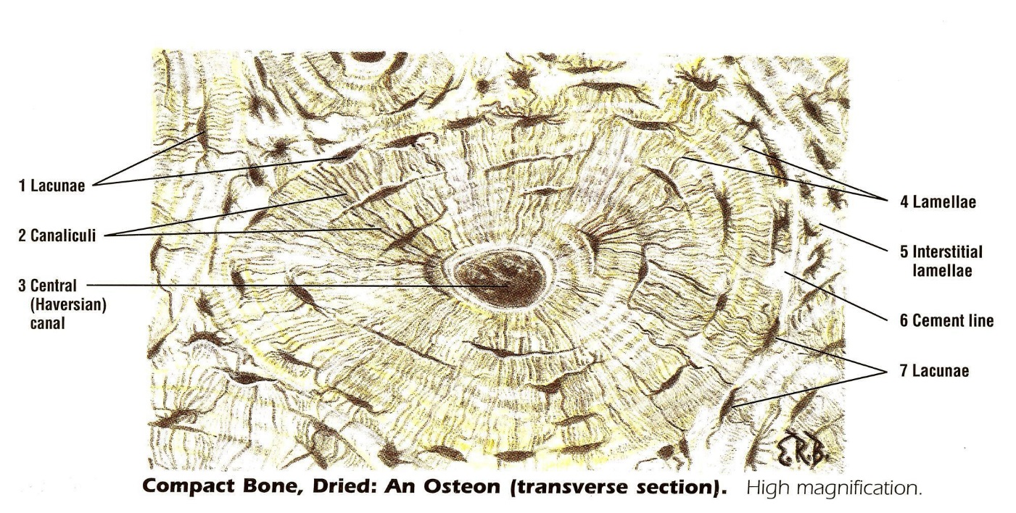**Describe the histology of compact bone including the osteon / lamella / Haversian canal / lacunae.**

5. Body Movements:

**Describe and show the body movements below:**

Abduction

Adduction

Flexion

Extension

internal rotation

external rotation

Dorsiflexion

Plantar flexion

Ulnar deviation

Radial Deviation

Opposition

Circumduction

Pronation

Supination

6. What are 5 functions of the skeletal system?

What are the four types of bone cells and their functions?

Define:

Wolff’s Law

Endochondral Bone

Trabeculae

Hematopoiesis

7. Describe the structure of a long bone and be able to label each part in a picture AND its function ex. Periosteum

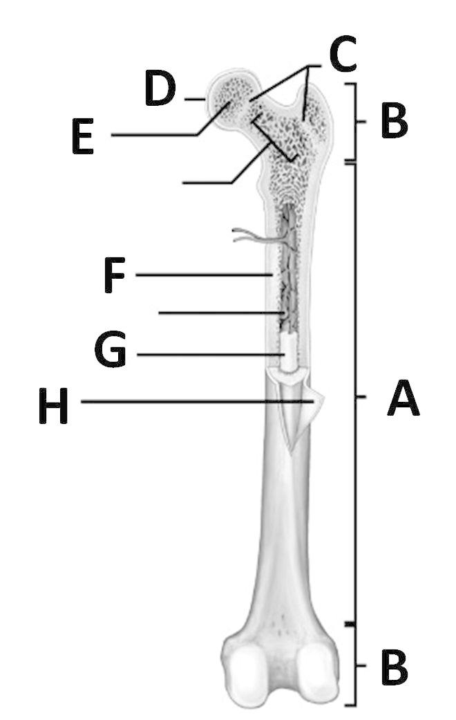

**8. Describe the four steps of how a bone heals following fracture.**

What are the 3 types of cartilage and describe where you can find each

What are the differences between the 3 structural classifications of joints (and what are they?)

Define:

Epiphyseal plate/ Endosteum/Ossification

**9.Types of joints – What movements does each allow? Where can you find each?**

**Hinge**

**Pivot**

**Ball and socket**

**Saddle**

**Where do you find synovial joints? What are the parts of a synovial joint?**

