The Respiratory System

Sketch the Major parts of the respiratory system indicated on page 802 of the textbook. Including right and left lung, primary bronchi, trachea, pharynx, larynx, and nasal cavity. Use page 805 to define the function of each. Use the book to color the respiratory zone one color and the conducting zone a different color

Structure of the lungs: Use page 816-817 or google search” pleura of lungs”
- What is the difference between the visceral and parietal pleura?

- What lies between them? Why do you need it?

- What is pleurisy?

Use page 818 or google search: “figure 22.13 changes in thoracic volume and sequence of events during inspiration and expiration” to answer.
- Write a paragraph on how we are able to breathe in specifically.

- Write a paragraph on how we are able to breathe out specifically.

5b. How do we do forced expiration? (pg 819)

Use page 811 or google search to answer number 6 and 7.
- How does the tissue of the walls of the bronchi change as they tubes become smaller and smaller in the lungs?

- What is surfactant and why do we need it?

Respiratory Volumes: To measure lung function, patients are tested using lung spirometry. These measure the amount of air moved out of lung during expiration and into the lungs during inhalation. You can measure both normal breaths and forced inhalation and exhalation. Use pg. 822 to answer the following questions or search figure “22.16 respiratory volumes and capacities”.

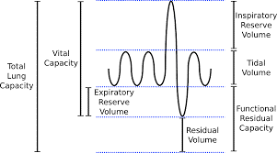

What do each of the lung volumes indicate?
- Tidal Volume:
- Residual volume:
- Inspiratory Reserve volume:
- Expiratory Reserve volume:

How do you calculate?
- Total lung capacity:
- Vital capacity:
- Inspiratory capacity:

Lung Volume Practice: Use the formulas and chart on the previous page to answer.
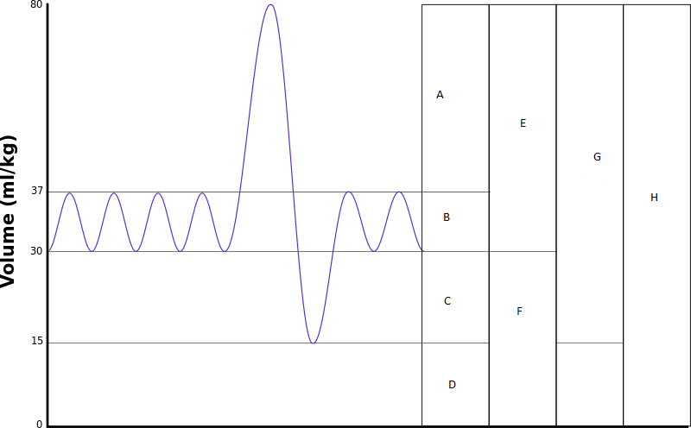
5.6
2.7
1.9
1.1
0
Liters of air

Calculate the amount of air per normal breath (tidal volume)

Calculate the inspiratory capacity

Calculate the expiratory reserve

Calculate the vital capacity of the individual

Calculate the total lung capacity knowing that the residual capacity is 1.1 in this individual.

