The Endocrine System

Sketch the Major Endocrine glands the body and indicate which hormones they create.
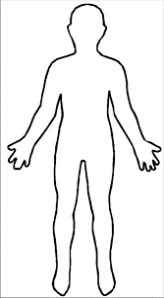

Model 1: Types of Glands
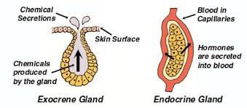

- What are the two major groupings of glands in your body?
- Where do exocrine glands secrete their product to?

- Where do endocrine glands secrete their products to?

- Which type of gland produces Hormones?

Model 2: Types of hormones
Peptide Hormones
Steroid Hormones
Amino Acid Hormones
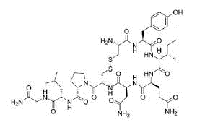
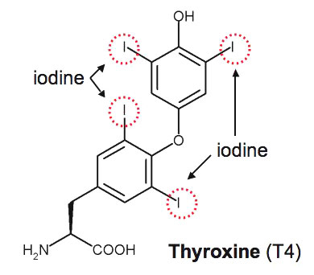

- What are the three classifications of hormones?

- Which type of hormone is thyroid hormone?

- Polar Molecules have more Oxygen and Nitrogen in their structure. Is thyroid hormone polar or nonpolar?

The Hypothalamic – Pituitary – Thyroid Axis

Model 2: The Thyroid gland is able to regulate your body’s energy production in response to triggers such as stress and cold using a hormone cascade.
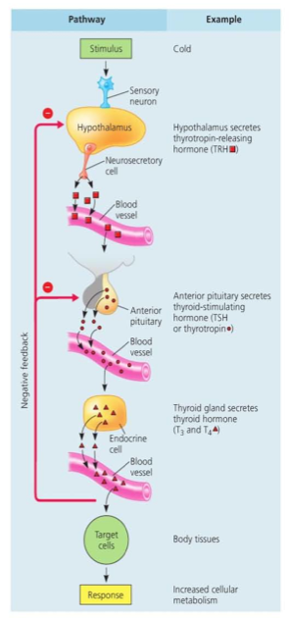
- What is the stimulus that starts the thyroid hormone production?

- How does the endocrine system “sense” the stimulus?

- What three hormones are used in the HPT axis?

- ___________ from the ______________
- ___________ from the ______________
- ___________ from the ______________

- How does each hormone get to a gland?

- Why would this process be called a hormone cascade?

- What type of feedback is controlling this loop?

- How do you know?

- What is the response of increasing thyroid hormone?

Thyroid Hormone Action
MODEL 3:
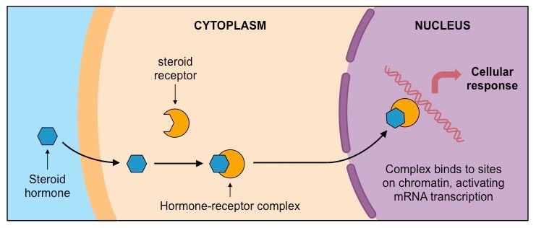
Steroid or amino-acid hormone binding target cell
Peptide Hormone binding target cell
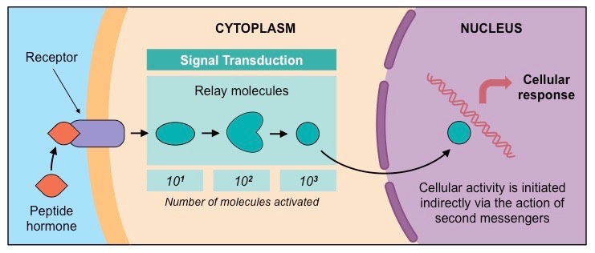
16. Which type of hormone cannot enter a cell without a receptor protein? Why?

17. What happens in the cytoplasm for non-steroid proteins to the number of relay molecules?

18. Why would steroid hormones be able to pass straight into a cell?
19. Look back at the answer to number 6. How is thyroid hormone going to reach the nucleus?
20. What is the response of thyroid hormone’s target cell going to be?
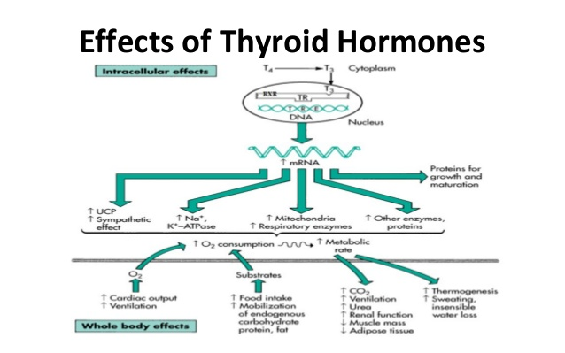
21. How does thyroid hormone response differ from that of the nervous system?

22. Does thyroid hormone increase or decrease the following?
Oxygen consumption _______ Metabolic Rate ______ Fat production ______ Heart Rate ________
Heat production ________ Enzyme production ______ Muscle mass _______

23. Hypothyroidism is underproduction of thyroid hormone. Predict symptoms of this based on the above information.
Weight: Energy Levels: Digestion:
Sensitivity to cold: Heart rate and blood pressure:

24. Why do you think thyroid medication takes several days to have an effect on a patient?

25. Do you think uncontrolled hypothyroidism or hyperthyroidism would be more dangerous for your heart? Why

